DS 6373: Time Series: Unit 2 HW Solutions

Below are the homework (HW) problems for this Unit. You do not need to submit the solutions rather double check your solutions to the solutions posted. Solutions will be posted to the Wall a few days after the release of the HW. This is intended to let the student think about the problem and attempt it without the temptation to first look at the solution. Please write any questions to the Wall or in an email to myself and/or bring them up during office hours or even in the next Live Session. Remember that the concepts covered below are fundamental to the course and are fair game for the midterm and final.

Have a blast!

Problems from the Textbook:

1.5

1.6 d

Solutions:

1.5 The data set fig1.21a in the R package tswge contains the realization of length *n* = 250 shown in [Figure 1.21a](javascript:void(0)). Notice that the data and the spectral density (but not the autocorrelations) show evidence of two frequencies, a lower one at about *f* = 0.05 and a higher frequency of about *f* = 0.33. Find the Parzen spectral density estimate for this realization with *M* = 31. Plot this spectral density estimate in dB (10 log 10) and again without taking the logarithms. Comment on the information visible in the spectral density estimates concerning the two dominant frequencies. What impact has plotting the logarithm (as dB) had?

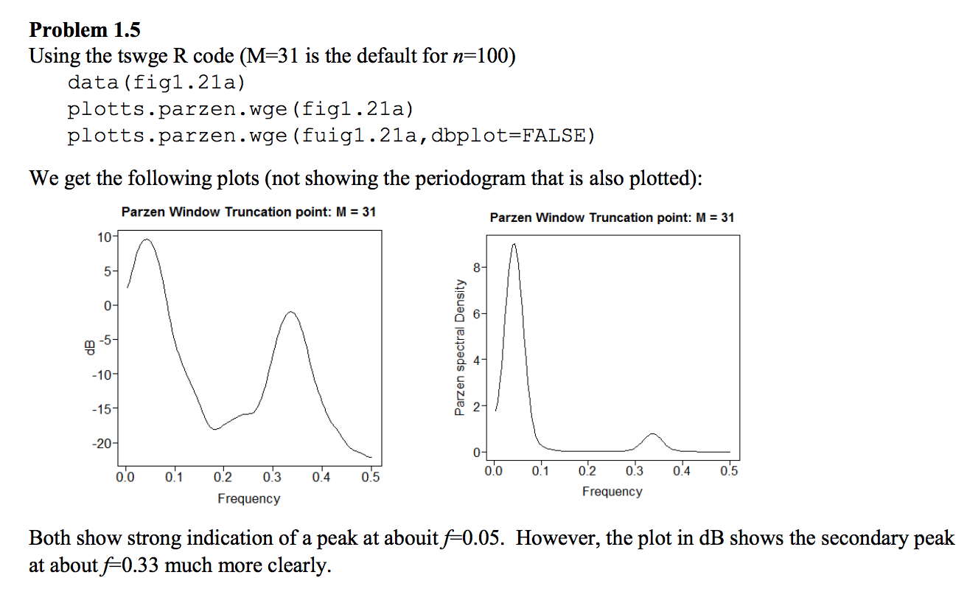

1.6 Generate a realization of length *n* = 100 from the signal-plus-noise model



where *at* is *N*(0,1) white noise.  
For these data, plot the

a.Realization

b.Sample autocorrelations

c.Periodogram

d.Parzen window spectral density estimator with default truncation point

